Which Age Groups and Gender are more prone to Coronary Heart Diseases?

Bhagya Lakshmi Patchipalu
Big Data Analytics
Saint Thomas University
Miami Gardens,Usa
bpatchipalu@stu.edu

Sharma Nikki
Big Data Analytics
Saint Thomas University
Miami Gardens,Usa
nsharma@stu.edu

Manisha Murella
Big Data Analytics
Saint Thomas University
Miami Gardens,Usa
mmurella@stu.edu

Abstract— The growing population with technology advancing failed to maintain the required health standards. Based on a report from WHO, 12 million deaths occur worldwide every year and one person dies every 34 seconds in USA due to a heart disease. A foundation of preventing cardiology is identifying the individuals at risk for it. Formulating a model that helps predict the individuals at stake for disease, improves the accuracy of medical diagnosis and help eradicate the medical errors is the main idea of the project. Predicting whether the patient has 10-year risk of future coronary heart disease (CHD) by using Classification Techniques such as Logistic Regression, Decision Tree, Naïve Bayes and KNN algorithm was done. Cluster Analysis grouped the individuals into 15 groups containing individuals with and without diseases. Text Analysis determines the disease which was recorded mostly in the cases of individuals affecting by a heart stroke. Of all the models used Naïve Bayes model has got the highest accuracy of predicting the coronary heart disease over a period of ten years.
Keywords— heart stroke, risk, analysis, techniques, data mining.

Introduction
Heart is the pumping organ of the body which plays a major role for the livelihood of an individual. Nearly 80% of deaths that occur in the world are due to cardiovascular diseases. Prevalence of various health maladies increased with cardiovascular disorders standing at the top of the list. Medical diagnosis is considered to play a major role yet complicated task which needs to be precise and accurate. Affected by a heart disease, people visit the doctor and all doctors do not possess the experience of giving the accurate diagnosis and the diagnosis made by them might not be accurate. False negative diagnosis of the disease might lead to improper treatment which persuades miserable consequences. In these cases, possessing a computer-based information or decision support systems can help achieve exact diagnosis and decrease the medical tests cost.
The risk factors for heart disease

Family history of heart disease: Most people know that the heart disease can run in families. That if anybody has a family history of heart disease, he/she may be at greater risk for heart attack, stroke and other heart diseases [3]
Smoking: Smoking is significant reason for cardiovascular failure, stroke and other peripheral arterial sickness. Almost
40% surprisingly who die from smoking tobacco do as such due to heart and arterial diseases [3][5]
Cholesterol: Increased levels of lipids (fats) in the blood are considered to be a hazardous factor for heart diseases. Cholesterol is a delicate, waxy substance found among the lipids in the circulation system. Cholesterol accelerates Atherosclerosis (clot formation in the blood vessels) increasing the danger of heart illnesses [3] [5]
High blood pressure: Hypertension otherwise called High blood pressure is a generally misjudged medicinal condition. Hypertension increments the danger of the dividers of the vein’s, dividers turning out to be overstretched and harmed. Additionally, it increases the danger of having cardiovascular failure and causes heart failure, kidney failure and peripheral vascular sickness [1][3]
Obesity: The term obesity is used to describe the health condition of an individual significantly above his or her ideal healthy weight. Being obese puts anybody at a higher risk for health problems such as heart disease, stroke, high blood pressure, diabetes and more.[4][5]
Lack of physical Exercise: Absence of regular exercise in daily routine is a risk factor for creating coronary artery disease (CAD). Absence of physical exercise increases the danger of CAD, since it likewise builds the risk for diabetes and hypertension too [4]

Finding out which Age groups and genders are more prone to cardiovascular stroke can help doctors differentiate the people at risk for the disease and proceed further accordingly with the treatment. The various sub problems as finding the highest probability of an individual getting affected by a cardiovascular stroke over a period of ten years and finding the age groups and genders more prone to the disease can be answered using Classification Techniques such as Logistic Regression, Decision Tree, Naïve Bayes and Cluster Analysis. The overall approach for solving all these problems is by performing various analysis using Decision Tree, Logistic Regression, Naïve Bayes, Linear Regression, KNN algorithm and Text Analysis.
Prediction models as of now suggested by clinical rules are commonly founded on a predetermined number of indicators with lacking execution over every single patient gathering [1]. To understand the complex interaction between the predictors of cardiovascular diseases, the Machine Learning techniques could potentially improve the performance of risk prediction between the patient group. As indicated by the WHO, ischemic stroke (IS) is the third driving reason for death in Western nations, and the first reason for incapacity in quite a while, notwithstanding having a high Morbi-mortality rate. Generally, prediction models of in-medical clinic mortality in ischemic stroke have concentrated on single patient factors, irrespective of other hospital relevant factors [2]. Every now and again utilized scores are better indicators of risk of previous disease than mortality, and, until this point in time, the utilization of basic conditions in expounding such measures has just been narrative [2]. Technology advancement helps identify the early detection of medical treatments and causes.

LITERATURE REVIEW
The data produced for predicting the cardiovascular stroke is complex and voluminous to be processed and broke down by conventional techniques. Data mining gives the technique and innovation to change this huge amount of data into helpful data for decision making. By using data mining techniques, it takes less time for predicting the disease with more accuracy. In this paper there is an overview from various papers in which at least one analysis of data is utilized for the prediction of coronary illness. Most of the approaches used shown in different papers shows utilizing neural systems, support vector machines and regression analysis [4][6]. The expectation is, utilizing data mining methods gives productive outcomes. Applying data mining and machine learning procedures to cardiovascular illness treatment data can give strong execution as that accomplished in diagnosing coronary illness. The use of traditional methods has various limitations when comparing different patient’s data with heart diseases.
Previously a few examinations were conducted in man-made brainpower subject on heart patients' information, and a significant number of calculations were effective which were referenced earlier. Be that as it may, the significant point is that the degree of achievement in these calculations relies upon different elements and it is beyond the realm of imagination to expect to pick a strategy as the best one. Elements like information kind of database, choosing a subset of properties and hazard factors, number of properties, the bigger size of database, low number of missed information and access to appropriate and address information builds the achievement chances in investigation and increment the nature of calculations outcome. In this subject they could specify to cases which improves the calculation including utilizing self-versatile neural system, which was acquired from fuzzy clustering, or utilizing a mix of grouping and SVM characterizing, and utilizing fuzzy principles disclosure on heart patient’s information [11].Therefore an early detection of heart stroke prevention would help understand the cause of the age group and gender which is most affected. This analysis would also help detect the causes that are prevalent for the cardiovascular stroke or diseases.
Many authors conducted extensive research and analysis for predicting the stroke rate. Hlaudi Daniel Masethe and Mosima Anna Masethe performed prediction of heart disease using classification algorithms like J48, Naïve Bayes, REPTREE, CART, and Bayes Net. The examination results show forecast precision of 99%. The prescient precision controlled by J48, REPTREE and SIMPLE CART calculations recommends that parameters utilized are dependent variables to anticipate the proximity of heart diseases ailment. Khosla, Aditya & Cao, Yu & Lin together used Integrated Machine Learning approach to stroke prediction. Support Vector Machine (SVM) was used by them for classification for stroke prediction occurrence over a time frame. An Average test AUC using diﬀerent algorithms with comparison to the Cox models gave average test AUC of 0. 777. Average test concordance index of Cox model and MCR (Margin-based Censored Regression) using diﬀerent sets of features gave Concordance Index of 0.770.
According to them when considering the Concordance Index the result was 0.77 which was again better than other diﬀerent algorithms with comparison. Douglas G. Manuel and Meltem Tuna conducted Predicting Stroke Risk Based on Health Behaviors: Development of the Stroke Population Risk Tool (SPoRT). Cox proportional hazards model was utilized to test the significance of every potential risk factor on the risk of incident stroke. A 12% increase in stroke for men and a 14% increase in stroke for women. Men had increases in stroke risk of 37% for previously diagnosed hypertension, 36% for heart disease (women, 44%) and 29% for diabetes (women, 74%). The final model C-statistic, assessing discrimination, was 0.85 (95% CI 0.83–0.86) for males and 0.87 (95% CI 0.85–0.88) for females.
To prevent patients from being affected by heart stroke, classifiers like Decision Tree can help in early detection of the vulnerability of a patient to heart stroke. Logistic Regression, Naïve Bayes algorithm and KNN algorithm are used to foresee the probability of a patient being affected by heart stroke. Clustering technique, simple k-means algorithm is used for patients who can be forewarned that, specific age group which is more susceptible to the stroke need to take special care and change their habits like smoking, exercise plans and taking healthy nutrition infused food. This could result in preventing patients being affected by heart diseases/stroke, thereby resulting in low mortality rates as well as reduced treatment costs in health sector in the country. Text Analysis was used to identify the most recorded disease associated with heart stroke in individuals.

METHODOLOGY
The data analyzed in the study derives from the historical statistics from Kaggle of heart study-dataset and it is from an ongoing cardiovascular study on residents of town Framingham, Massachusetts which consists of various patients records. The dataset provides the patient’s information including their heart rate, blood pressure, glucose and cholesterol levels etc. It includes over 4,238 records and 16 attributes. Each attribute is a potential risk factor. There are demographic, behavioral and medical risk factors associated. The key variables or risk factors for heart disease and stroke are: High blood pressure, High cholesterol, Cigarette smoking, Diabetes, Unhealthy diet and physical inactivity, Overweight and obesity. Cigarettes consumption per day by gender can be seen from the plot below (Fig:1). Males consume more cigarettes when compared to females.

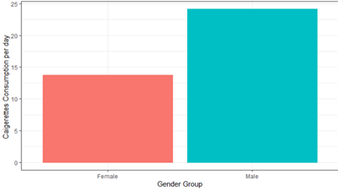

Fig:1. Cigarettes consumption per day by Gender

Variables Gender and Diseases types are character data type whereas the rest of the variables selected were numeric. In the data, for the Gender variable,0 denotes Female and 1 denotes Male. Age denotes the age at the same time. Education was categorized as1- some high school,2-High school,3-Some college or vocational school,4-college. An individual was considered as a smoker when its denoted as1 and non-smoker when 0. Cigs per day means the number of cigarettes a person consumes per day. For denoting whether a person is on medication for blood pressure was given by 0 for people not on any medication for blood pressure and 1 for people on medication for blood pressure. Prevalent stroke denotes the previous stroke history of the individual. Prevalent hypertension gives information about the hypertension record. Diabetes tells whether a person is affected by diabetes or not, 0 denotes people free from diabetes and 1 denotes people with diabetes.
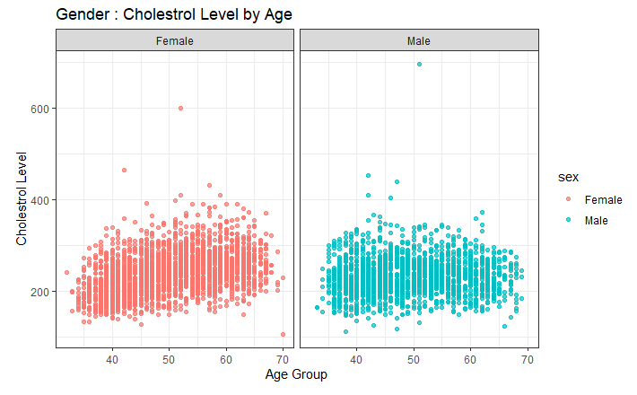
Fig:2. Cholesterol level by Age & Gender

Total cholesterol is the amount of cholesterol a person has measured in mg/dl. Total cholesterol levels by Age and Gender can be observed from the plot above (Fig:2.) Females have more cholesterol when compared to males.
SysBP gives information about the systolic blood pressure of a person measured in mmHg. BMI tells the body mass index calculated as weight(kg)/height(meter-squared). Heart rate denotes the number of beats per minute in a resting state of an individual. Glucose tells glucose levels in blood measured in mg/dl. Diseases type gives information about the disease an individual is suffering from Ten Year CHD is the prediction whether an individual can get affected by coronary heart disease over a period of ten years.
Linear Regression was used to find the relationship between the factors affecting the heart disease. A linear relationship is used (or linear association) with statistical approach between a variable affecting the heart diseases. Also, it can be used to identify whether any change in one of the independent variables will produce a corresponding
change in the dependent variable, i.e. Heart rate. From the plot below (Fig:3.), Actual Vs. Predicted values for heart rate can be observed.
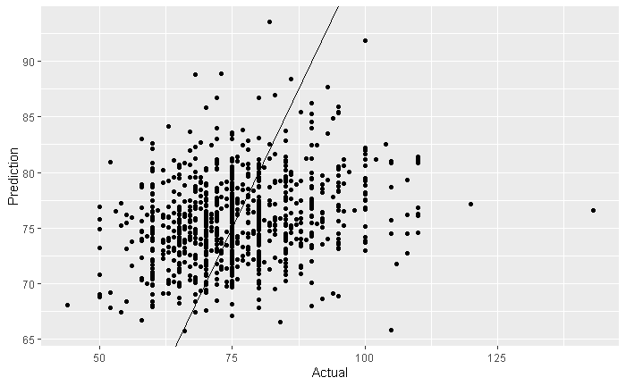
Fig:3. Linear Regression Plot

Logistic Regression was done to find the probability of the patients getting a coronary heart disease. This results in the possibility of heart diseases dependent on predominant elements and about the happenings of event that has occurred previously. Clustering is a data mining procedure that causes important or valuable group of items that to have comparable characteristics utilizing programmed method. Clustering Analysis is a simple k-means algorithm which
grouped the individuals into 3 groups which are 30-45,45-60 and 60-75(Fig:4). It was performed to forewarn that, specific age group which is more susceptible to the heart disease and warn them to take special care and change their habits like smoking, exercise plans and taking healthy nutrition infused food.
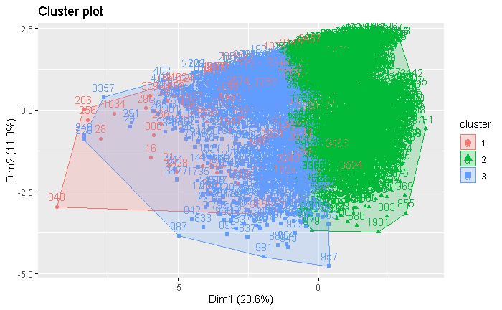
Fig:4. Cluster Plot by Age Group

The Bayes theorem calculates the conditional probability, to find the possibility of existence of the heart disease among the patients. This is the probability of heart diseases based on prevalent factors and about the events occurrence in the past. Decision Tree was used to predict whether the patient has 10-year risk of future coronary heart disease (CHD). Decision Tree creates a training model, which will be used to predict the class of heart diseases by learning decision rules inferred from historical data. Decision tree takes the first variable into account which is Age. When Age is < 48 it checks the next variables cigs per day and systolic blood pressure. If the age is > 48 years the model traverses down the tree checking all the variables it selected. Finally, it predicts the probability of an individual getting affected by heart stroke or not.

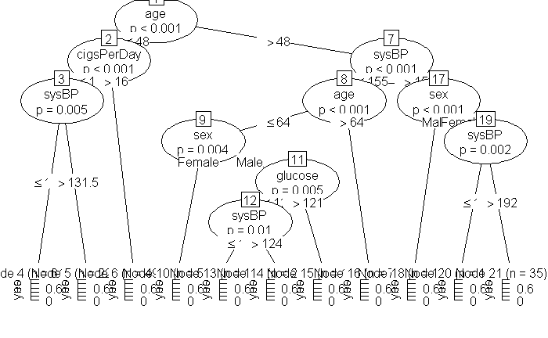
Fig:5. Decision Tree

Text Analysis is a classification task that, when considering a pair of entities like diseases that co-occur in the group of different patients, it tries to categorize the relations based on a predefined list or classification of relations. Text Analysis was used to identity the most recorded disease associated with individuals getting affected by coronary heart disease (CHD) so that a general view can be obtained regarding among all the diseases which particular disease could mostly lead to a coronary heart disease on the whole. Cardiomyopathy and COPD are the two diseases mostly associated with the individuals getting affected by heart stroke over a period of ten years.
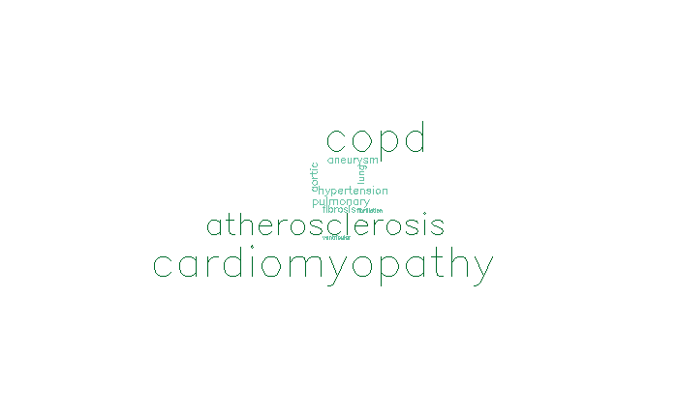
Fig:6. Text Analysis

The data is structured .The file is in CSV format (Comma Separated value). The data will be extracted to SQL server which is hosted on Amazon Web Services (AWS). Extracting, loading and transforming the data was the order that was selected for the data to be used. The first step before organizing the data is pulling data from all the relevant sources and compiling it. These sources include structured CSV data files which will be used for analytical processing. The data is structured and formatted based on the data analysis requirement. Data Transformation is the second step of the ETL process. Here the compiled data is fed into the database that is on the SQL server which is hosted on Amazon Web Services (AWS) and then will be connected to R studio for statistical analysis- where data is converted, reformatted, and cleansed in the staging area.(The missing values can reduce the statistical power of a study and can produce biased estimates, leading to invalid conclusions hence we will be removing the missing values from the data.) The last step is of loading the datasets that’ve been extracted and transformed earlier, into the SQL database. The data collected in CSV format which is stored in SQL which is hosted on Amazon Web Services (AWS) and is the extracted in R studio to perform the statistical tests on the dataset.

RESULTS
Linear regression was used to predict the Heart Rate based on one or more input predictors prevalent to the cardiovascular stroke. Backward elimination, forward elimination and R squared methods were used to select variables to build the model. Linear regression model predicted the heart rate of males and females based on the given input variables. The predicted heart rate for males and females was 115.89 beats/min and 119.18 beats/min respectively. Of all the variables considered the most important variable was diseases followed by age and systolic blood pressure. Using the Logistic regression prediction of a patient getting affected by a coronary heart disease in ten years was done using various input variables such as age, systolic and diastolic blood pressure, total cholesterol, BMI, prevalent hypertension status and glucose levels of the patient.
Logistic regression model gave an accuracy of 84.68%, precision of 15.20 % and recall of 50%. Using Decision tree model prediction of ten-year coronary heart disease was done which gave an accuracy of 83.80 %, precision of 15.20% and recall of 50%. Naïve Bayes model gave a prediction with an accuracy of 94.63 %, Precision of 15.20% and recall of 50%. Prediction of heart stroke by KNN algorithm gave an accuracy of 86.10%,precision of 13.89% and recall of 50%.
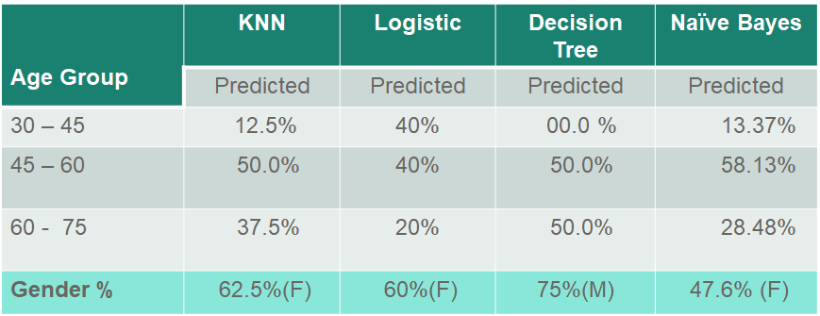

Table:1. Prediction of Age groups and Genders more prone to CHD

From the table above (Table:1) Age group of 45 to 60 has the highest chances of getting affected by a heart stroke when compared to other Age groups of 30 - 45 and 60 -75. According to KNN and Decision tree there is 50% chance of an individual in the age group of 45 to 60 to get a heart stroke and 40% chance and 58.13% chance of stroke according to logistic regression and Naïve Bayes. Individuals between Age 30 to 45 have less chances of getting heart stroke when compared to other age groups where as those between 60-75 age have 50% chance according to Decision tree, 37.5% by KNN, 20% and 28.48% by logistic regression analysis and Naïve Bayes model. Text Analysis determined Cardiomyopathy and COPD as two diseases mostly associated with CHD.
The significant differences between each of the models was tested using ANOVA (Analysis of Variance). P value of ANOVA is 2.45e-13. As, P value is less than 0.05 there is no significant difference between the models. The accuracy, precision and recall of the different models can be seen from the table below (Table:2). The plots show the comparison between the different models (Fig:7), (Fig:8).

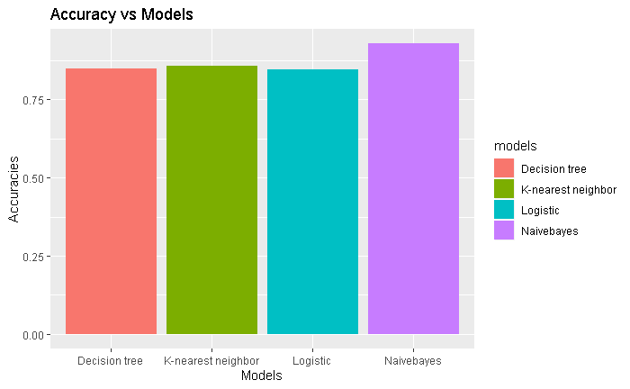
Fig:7. Bar plot of Accuracy Vs. Models
MODEL | ACCURACY | PRECISION | RECALL
Naïve Bayes | 94.63% | 15.20% | 50%
KNN Algorithm | 86.10% | 13.89% | 50%
Decision Tree | 83.80% | 15.20% | 50%
Logistic Regression | 84.68% | 15.20% | 50%

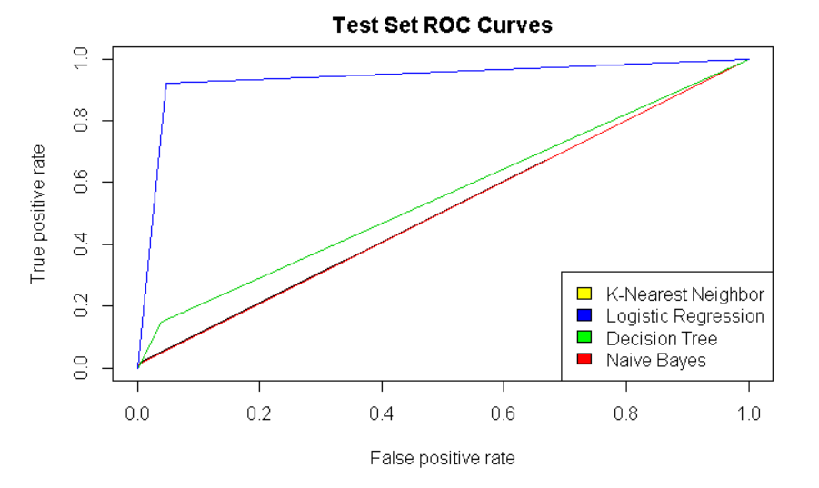
Fig:8. Performance of different Models

ROC’s curves are used to characterize the sensitivity/specificity trade offs for a binary classifier. Fig:8 shows True positive rate against False positive rate.

CONCLUSION
Data Mining is fundamental concern about the analysis of data. Data Mining tools and techniques are utilized for finding patterns from the dataset. The main objective of Data Mining technique is to discover patterns automatically with minimal user information. Linear regression model answered whether males or females possess a higher risk for getting affected by heart stroke. Females were predicted to have a greater possibility for heart stroke when compared to males when both the genders with the same factors affecting the stroke were considered. The individual statistics of prediction of one’s chances of getting affected by stroke over a period of ten years was predicted using decision tree, Logistic Regression, Naïve Bayes model and KNN algorithm.
Each of them had their accuracy, precision and recall values. As discussed earlier Naïve Bayes model predicted the heart stroke at an accuracy of 94.47%,precision of15.20% and recall of 50%.The next highest accuracy of prediction was obtained by using KNN algorithm which gave 86.10% accuracy, precision of 13.89% and recall of 50% .Decision tree and logistic regression gave an accuracy of 83.80 % and 84.68% respectively. Precision of logistic regression being 15.20% and recall of 50%. Decision tree gave a precision of 15.20% and recall of 50%. By using cluster analysis grouping of the individuals was done based on their Age into 3 groups which are individuals between 30 to 45,45 to 60 and 60 to 75 age. Text analysis denoted the most recorded diseases in the cases of coronary heart disease. Cardiomyopathy and COPD were the two most recorded diseases associated with the patients getting affected by coronary heart disease in the next ten years.
Individuals between 45 to 60 years of age are more prone to cardiovascular stroke when combined with other factors

such as cholesterol levels, systolic blood pressure, cigarette consumption per day etc.
The Analysis performed above could help doctors to provide an accurate diagnosis when a person suffering from different

Table:2. Comparison of Accuracy, Precision & Recall
of different models
cardiac symptoms visit them for treatment. Having a computer-based system to provide assistance towards diagnosis could considerably decrease the medical errors like false negative and false positive diagnosis of the patients. Also, by the results achieved from the analysis general information about the genders and age groups at risk for heart stroke were identified and further care can be taken by everyone to prevent heart stroke by taking necessary measures like decreasing the smoking tendency, exercising daily and practicing healthy life style. The next level of the analysis would be including other techniques such as Artificial neural networks (ANN), Fuzzy clustering, Random forests, Support Vector Machine (SVM) etc. to tune the accuracy. Since the data collected was confined other important factors were not considered. Multiple factors can be taken into account for predicting the heart stroke at a broader range in future analysis.

References

- Ahmed M. Alaa, Thomas Bolton,Emanuele Di Angelantonio,James H. F. Rudd,Mihaela van der Schaar, “Cardiovascular disease risk prediction using automated machine learning: A prospective study of 423,604 UK Biobank participants”, PLoS ONE, 2019.
- Jesús de la Fuente1, Juan Manuel García-Torrecillas3,4, Giulliana Solinas5, María Mar Iglesias- Espinosa6, Angélica Garzón-Umerenkova7 and Javier Fiz-Pérez8, “Structural Equation Model (SEM) of Stroke Mortality in Spanish Inpatient Hospital Settings: The Role of Individual and Contextual Factors”, FNEUR, 2019.
- Shadab Adam Pattekari and Asma Parveen, prediction system for heart disease using naïve bayes, International Journal of Advanced Computer and Mathematical Sciences, 2012.
- Douglas G. Manuel, Meltem Tuna,Richard Perez,Peter Tanuseputro,Deirdre Hennessy,Carol Bennett,Laura Rosella,Claudia Sanmartin,Carl van Walraven,Jack V. Tu , “Predicting Stroke Risk Based on Health Behaviors: Development of the Stroke Population Risk Tool (SPoRT)”, PLoS ONE, 2015.
- F Heller, S Chinn, H D Tunstall Pedoe, G Rose, “HOW WELL CAN WE PREDICT CORONARY HEART DISEASE? FINDINGS IN THE UNITED KINGDOM HEART DISEASE PREVENTION PROJECT”, BRITISH MEDICAL JOURNAL, pp. 1409-1411, 1984.
- Shadab Adam Pattekari and Asma Parveen, “PREDICTION SYSTEM FOR HEART DISEASE USING NAIVE BAYES”, ISSN, pp. 290-294, 2012.
- Jyoti Soni, Ujma Ansari, Dipesh Sharma, Sunita Soni, “PREDICTIVE DATA MINING FOR MEDICAL DIAGNOSIS: AN OVERVIEW OF HEART DISEASE PREDICTION”, ISSN, pp. 43-48, 2011.
- Carlos Ordonez, Edward Omiecinski, Mining Constrained Association Rules to Predict Heart Disease, IEEE. Published in International Conference on Data Mining (ICDM), p. 433- 440, 2001
- Kaur, Beant and Williamjeet Singh, " Review on Heart Disease Prediction System using Data Mining Techniques", International Journal on Recent and Innovation Trends in Computing and Communication, ISSN: 2321-8169 Volume: 2 Issue: 10 3003 – 3008
- Khosla, Aditya & Cao, Yu & Lin, Cliff & Chiu, Hsu-Kuang & Hu, Junling & Lee, Honglak, “An integrated machine learning approach to stroke prediction”, KDD, pp. 183-191, 2014.
- Abbas Nasrabadi, Javad Haddadnia, "Predicting Heart Attacks in Patients Using Artificial Intelligence Methods", ISSN, pp. 66-78, 2016.
- K.Vembandasamy ,R R.Sasipriya and E.Deepa, “HEART DISEASES DETECTION USING NAIVE BAYES ALGORITHM”, ISSN, pp. 441-444, 2015.

conference templates contain guidance text for composing and formatting conference papers. Please ensure that all template text is removed from your conference paper prior to submission to the conference. Failure to remove template text from your paper may result in your paper not being published

